DATA 468 Homework 5

Instructor: Zakir Ullah

Homework Date: May 19, 2025

Submission Date: May 25, 2025 (11:00 PM) (Beijing Time)

Submission Date in Gradescope: May 25, 2025 (8:00 AM) (Tucson Time)

**Instructions**: Please write or type your solutions clearly and show all relevant steps. Once you are done, please upload your solutions to Gradescope. If you need to scan your solutions, please use a free scanning app like CamScanner instead of sending photographs. Please submit your solutions within the prescribed time, as late submissions will be not considered.

1). Determine if the Chain in Fig 1, is an absorbing Markov chain.

2). Let's define ai as the absorption probability in state 1 if we start from state i, calculate the following abortion probabilities

i). a1=P(absorption in 1|X0=1),

ii). a2=P(absorption in 1|X0=2),

iii). a3=P(absorption in 1|X0=3),

iv). a4=P(absorption in 1|X0=4).

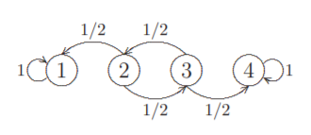

Fig 1. Markov Chain

3). Let's define ti as the number of steps needed until the chain hits state 1 or state 4, given that X0=i

i). Find the hitting times (t1 and t2).